[**sales@acuitysoftwareservices.com**](mailto:sales@acuitysoftwareservices.com)

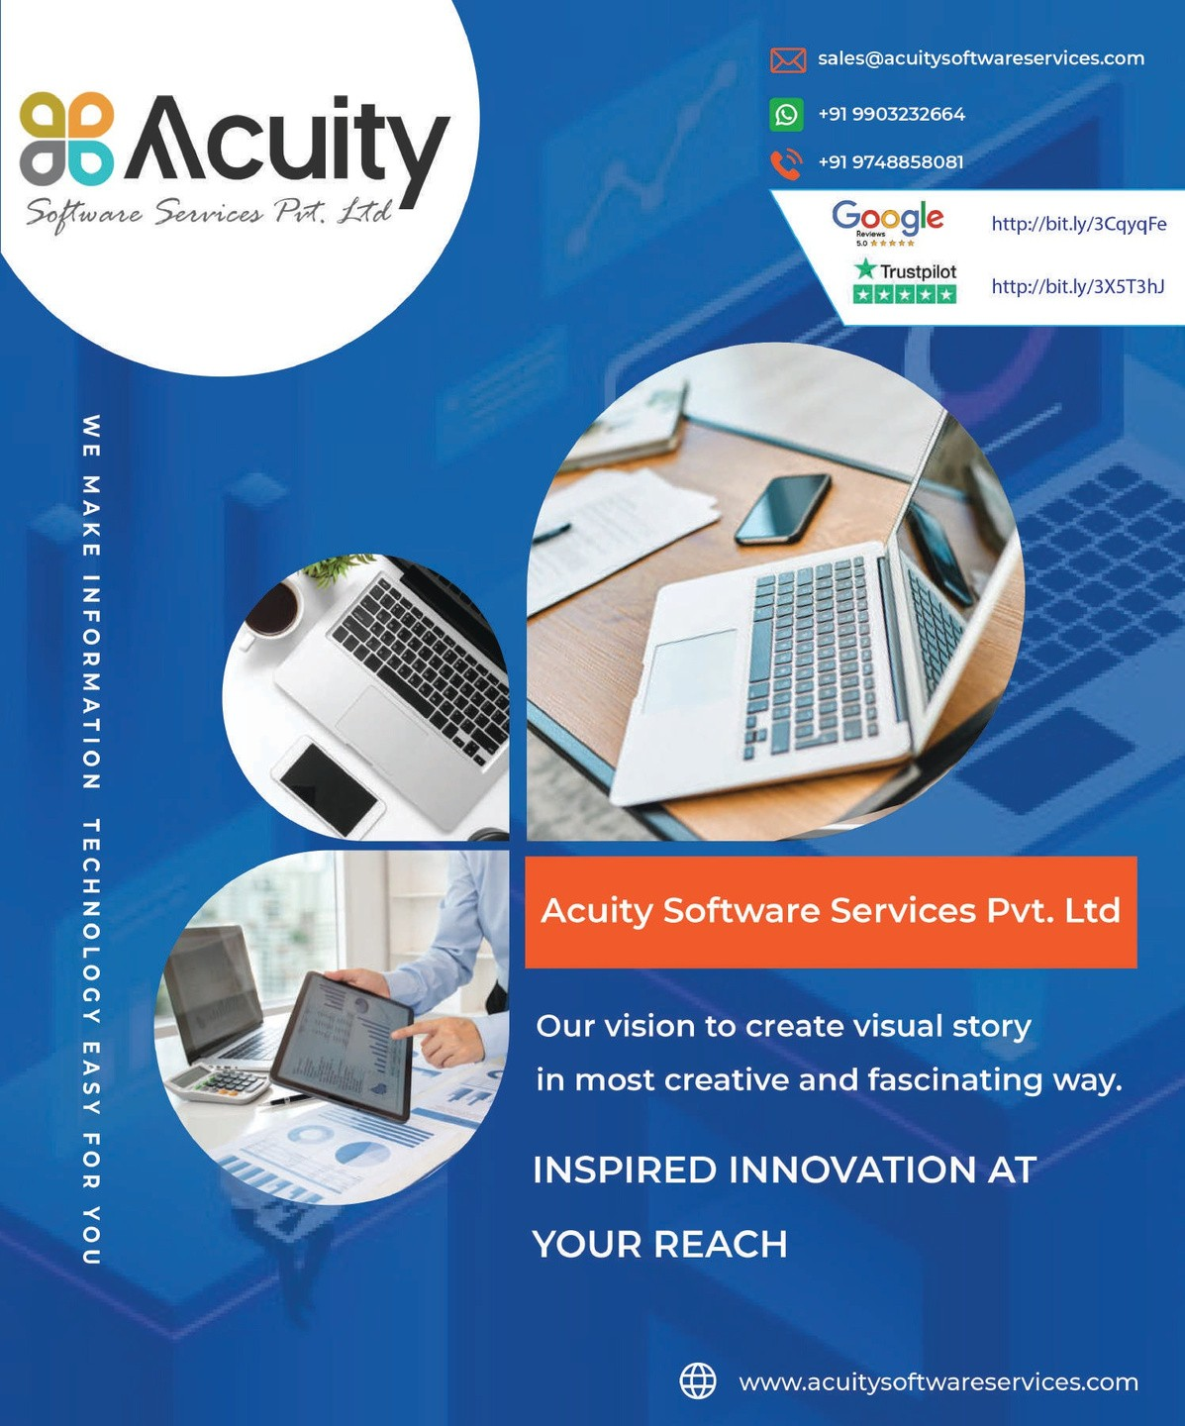

+91 6290544049

**+033 4814 5316**

**4.2**



ACUITY SOFTWARE SERVICES PVT LTD IS AN

**IT CONSULTING AND SOLUTIONS**

We, Acuity Software Services based on the business of software-related products & services have been serving our effort for the nation. We have been doing our ser- vices for a couple of years. We came into the business in the year 2014. Though we are located in Kolkata, we do our work for all the states & cities in India. Not only we are serving the people in our country but our team has been serving overseas

Clients also.

##### 900+

PROJECTS

##### 200+

CLIENTS

##### 60+

TEAM



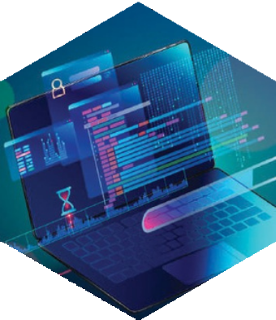

We, Acuity Software keep our values with our work through website development, website designing, and app development. We do the potential work for the whole nation. We keep our duties sincerely for the need of our customers.

We are named by Acuity Software, which has been running with the services of technologies focuses, we are working on website development, app development, website designing, and digital marketing. We do these with

a software team and digital marketing expertise.

#### FRAMEWORKS

React Native

**Codeigniter**

Wordpress

**Laravel**

#### LANGUAGE

NodeJS

**Angular**

Php



**Html**

**Css**

Jquer y

[www.acuitysoftwareservices.com](http://www.acuitysoftwareservices.com/)

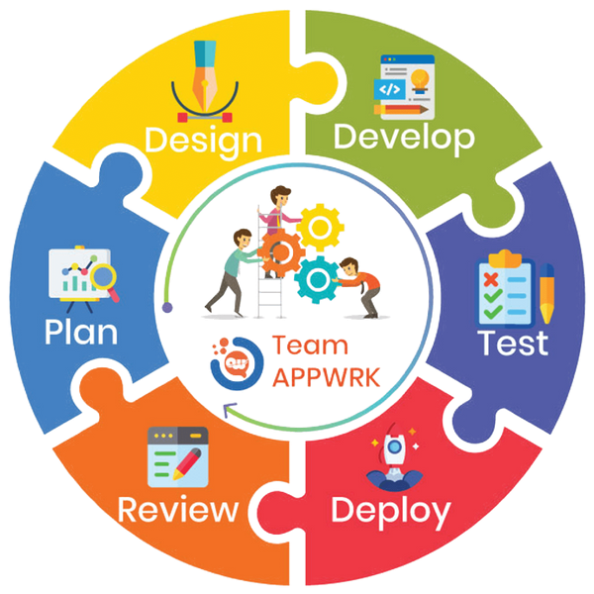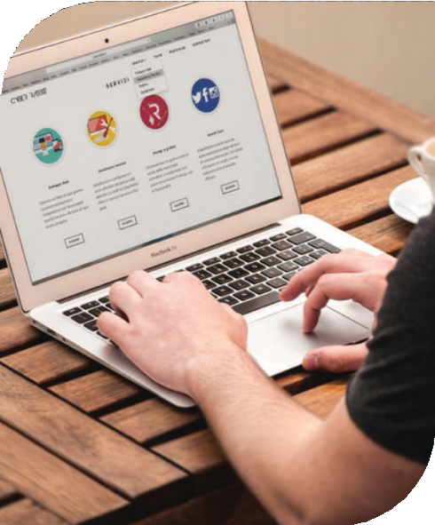

**HOW WE DO IT?**

We come to complete our work procedure with the help of technological team members. They are skilled and experienced and they know the value of time.

Within the time frame, they complete the work.





**W E M A K E I N F O R M A T I O N T E C H N O L O G Y E A S Y F O R Y O U**

WHAT DO **WE** DO?

###### Our main work goes to fulﬁll the basic aim of our customers and customer satisfaction is our ultimate goal. Generally, we do services for web development, web designing, Graphic designing, mobile application, and IT outsourcing. It is good to know that we have a strong determination to serve our customers at the extreme level and we can do it as we have several experienced and skilled IT professionals.

**We generally come to start our work for our clients when we can ﬁnish the discussion with them and come to know their ﬁnal requirements. As we got an exact idea from our client, we inform our professional to start the work immediately.**

###### Then they take a step to start their work on website designing, website development, and app development.

**Solve your ecommerce solutions with us For online buying and selling of different products or services or for transmitting data or funds with the help of an electronic network or internet is done with the help of ecommerce websites. Acuity Software Services deals with providing its customer with the proper ecommerce solutions.**

**WEBSITE DEVELOPMENT MOBILE APP DEVELOPMENT**

**Do you want any online presence with attractive features? Are you aiming at potential customers? Then, the ﬁrst and foremost thing that you will require is a proper website**

**The fast age of advanced technology is growing more and more and people are upgrading themselves.**

E-COMMERCE ONLINE STORE SEO/SMM/TRAFFIC/BRANDING

**The implemented projects on ecommerce solutions that we are associated with are practicing well in their business.**

**Business and marketing are related immensely. Marketing is not door to door advertisement these days, but in a digital way.**



**The age of IT or Information Technology is alluring most of theindividuals to choose the stream in order to get more options for the job. But, many companies do not have the IT professionals and so, they need to outsource**

**the IT professionals. The need of IT outsourcing is for delivering the IT-enabled business process or any application for better business outcomes.**



**Application Development**

**Custom Application Development Re-engineering & Migration**

We, Acuity Software Services, give importance to the clients and their work and for that, we try to ﬁnd out the solution on an urgent basis.



.



**E Commerce Solution**

**B2B Solutions**

**Store Front Solutions**



**Website Design Solution**

**Web Design Interface Design**



**Mobile Application**

**Andriod app Ios app**

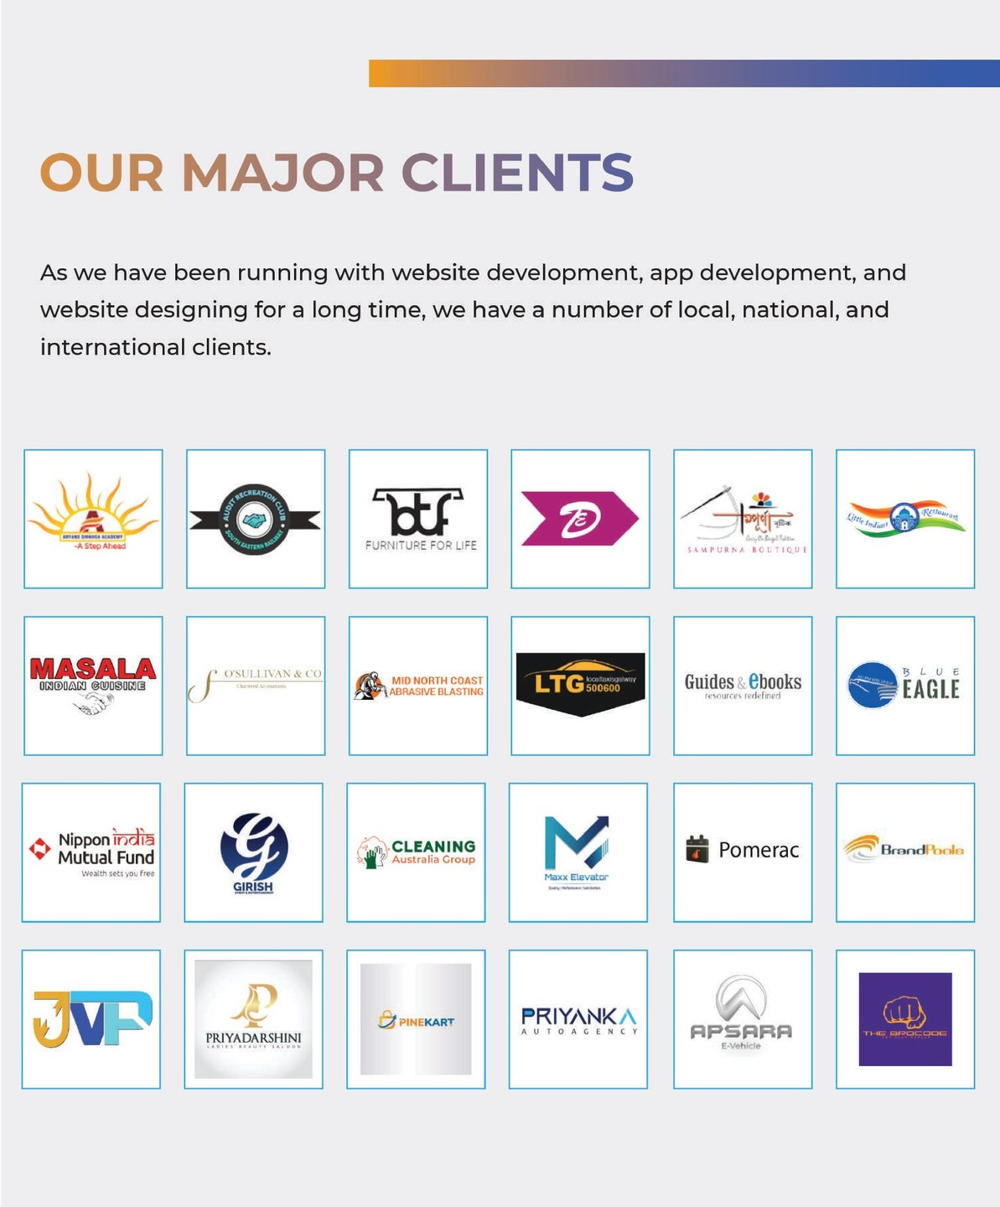

# Testimonial

Our happy clients send us a bunch of the testimonials and

**speaks with therating and we loved**

“ Navin Agarwal



L

It is a distinct pleasure for me to recommend Acuity Software to any and all interested parties. They have

been professional, comprehensive and competent throughout the process of our working together. feel that we have established a relationship with them. The reaction to our new web site has been overwhelmingly positive.



“

**GWCT**

I am in a business relationship with Acuity Software Services for

3 months only, I am doing Facebook,

Insta and YouTube marketing for Gramin CSP services, in this short period of time they has proved thier

Fully content with thier service.

excellence in Digital Marketing, I'm getting a lot of enquires.



“

**Salam Sk**

This software company very good company.. Service is so good & excellent

My experience is very good and all staff as helpful and highly experience..

“ chris okeke



L

Mr. Dennis Chen of Acuity Software Services Pvt. Ltd, assisted in creating our website and links to allow prospective clientele locate us .

# Testimonial

Our happy clients send us a bunch of the testimonials and

**speaks with therating and we loved**

“ RuX Pay Private Limited



L

I built a website for my business purpose. I am happy and highly satisﬁed about the quality of work and I also get support after delivery of my website from Acuity Software.

I highly recommend this company for Website and App development.



“

**vaishali Desai**

Working properly website and good behaviour and nice

support after website complete



“

**Vijay Shaw**

I did digital marketing. For my business purpose .

I am happy and satisfied about the Improvement and support provide by Partho Da. I recommend Acuity software for Digital marketing .

“ **Mallik**



L

I am a doctor, I have started doing digital marketing with Acuity Software Services, it's been 3 months and I have started getting good enquiries, I am fully satisfied

**Testimonial**

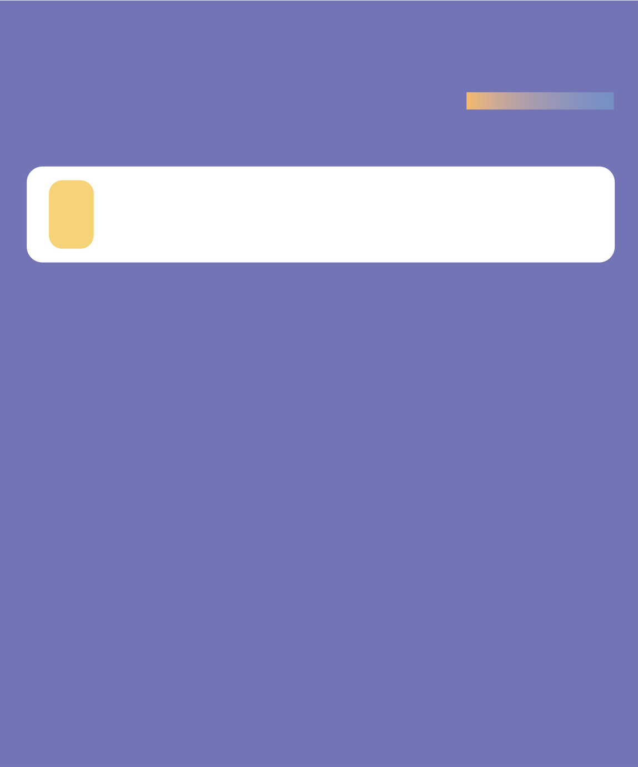

Our happy clients send us a bunch of the testimonials and

**speaks with therating and we loved**

Restor Body Massage

“

Great design team and quick turn around on all projects and request. With their help we have improved our website SEO for google search results. My company Titan has depended on them for quite sometime now and we have been doing business with them for over 10 years.

“ Jose Alvarez

L

I've been helped buen Acuity Software for the past 4yrs, and in particular Rom's professional advise and prompt service is to be commended. Their service have included Web pages development, online ordering system & hosting. Very competitive pricing. Highly recommend.

“ Queen Hair

The developers of Acuity Software Services Pvt. Ltd. are responsible, trustworthy, and capable.

By supporting the client's mobile application development side, Acuity Software Services Pvt. Ltd. has driven development time down, allowing the client to ship better software more quickly.

“

Mary Street Physiotherapy

L

Acuity Software Services Pvt. Ltd. has successfully provided complex online toolsfor the client's customers. Working in an agile methodology, they conduct regular meetings to deal with the project's dynamic requirements.

## Testimonial

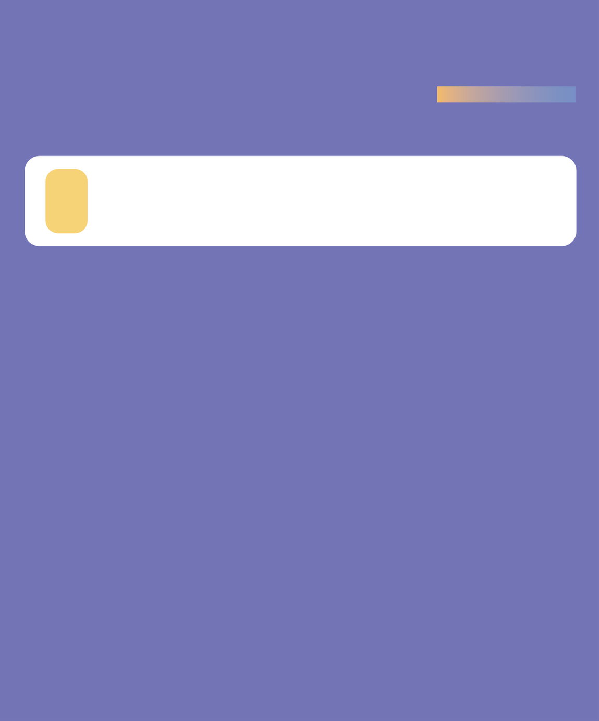

Our happy clients send us a bunch of the testimonials and

**speaks with therating and we loved**

“ GoldStone Insurance Services

They really are good at servicing you and delivering meaningful mobile application and digital marketing

services.While the launch of the produce was delayed due to the COVID-19 pandemic, the results met the needs and expectations of the internal team.

“ Smart Software

L

The project manager was helpful when we needed him, and our developer was brilliant with quick and clear communication.

“ Royal Smith

I am highly satisﬁed and happy to work with Acuity Software Services Pvt. Ltd for my Mobile App

development. The communication and work update provided by the project manager is brilliant. The most important thing is Acuity Software Services is very much professional and always use the latest technologies. I am writing this review after 6 months from the date of delivery.

“

CashFlow InvestorsPortal

L

Acuity Software Services Pvt. Ltd. has successfully provided complex online toolsfor the client's customers. Working in an agile methodology, they conduct regular meetings to deal with the project's dynamic requirements.

**Our Mission**

We are working with our team to fulﬁll

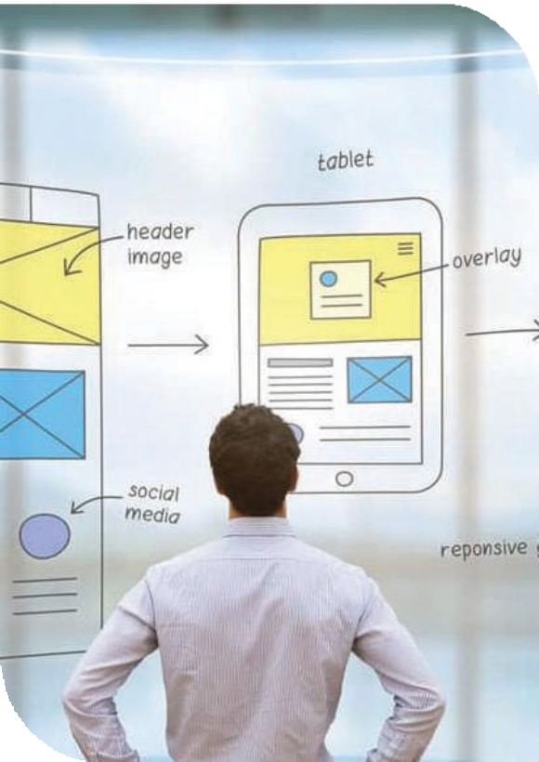the basic needs of our clients. As we have skilled and efﬁcient software developers, we have already got good feedback from our client. We have a strong determination to spread our area of working ﬁeld.

### Our Vision

Our future plan is to bring our services

to the zenith of the IT world and serve the nation. We will do our best and give our customers the best satisfaction for the next couple of years. We have strong conﬁdence in every professional as they work together and passionately.



Follow us on



To check our previous work

https: //acuitysoftwareservices.com/